Review for Integumentary System Test

Use the notes from class and the book when necessary

Be sure to review skin cancer. What causes it? Which type is most common? Which is most dangerous?

**5-1**

What percent of the body’s total weight is skin?

The body’s first line of defense is the _____________. List four examples of things that are constantly happening to the skin that the body must deal with.

The skin can be broken into 2 major components.

1. Cutaneous membrane = skin What are the 2 sub categories of the skin, and define them

__________________________________________________________________________________________

__________________________________________________________________________________________

1. Accessory structures, which consist of _________________________________________

Other things found in the skin include

a.

b.

c.

Label a cross section of the skin

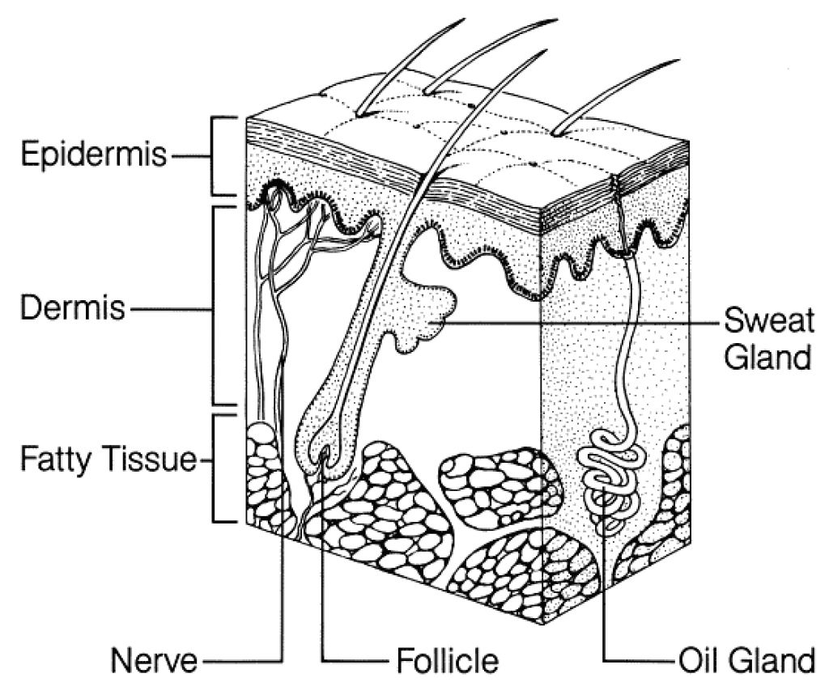

Describe/Explain at least 8 functions of the skin and hypodermis

1

2

3

4

5

6

7

8

True or False: The epidermis has no blood vessels.

True or False: The epidermis lacks keratin

Compare and Contrast thin and thick skin

Review check point questions 1 + 2 on page 162

**5-2 Pigmentation**

Describe the 2 pigments found in the Epidermis.

1___________________________

2___________________________

Areas in the skin where melanocytes are producing larger than normal melanin are called ____________.

Describe the major function of melanin in terms of UV radiation.

Describe 2 things that can happen if the skin is overexposed to UV radiation.

1

2

Are all skin tones protected the same way from UV radiation? Explain your answer

Name 2 effects of cumulative damage caused by exposure to UV radiation

1

2

Why is the depletion of the ozone layer of our atmosphere so dangerous?

Describe 3 ways in which an individual can protect themselves from exposure to UV radiation

1

2

3

Explain what makes a person appear flushed and what homeostatic mechanism the body is attempting to balance when it occurs.

When blood supply is restricted, a person appears ___________

What is cyanosis and what color does a cyanotic person appear?

Where is cyanosis most obvious?

Describe 2 conditions in which a person might appear cyanotic

1

2

What causes Jaundice?

What color does a jaundiced mammal appear?

In what area of the body is it extremely easy to notice when a person is jaundiced?

Name (and describe) four ways in which changes in skin color can be helpful in diagnosing a condition. Be specific in terms of those changes and what might be causing them to occur

1

2

3

4

Review point questions on pg 165, 6-8

**5-3**

Explain the importance of sunlight and bone strength.

What can happen if the body does not have a sufficient amount of calcitrol?

Explain why we add Vitamin D to our milk

Review checkpoint questions on page 165, 9 + 10

**` Strength and Elasticity of Skin**

Explain the function of collagen and elastic fibers

Collagen

Elastic

What is the term that is used to describe the flexibility and resilience of the skin? _______________

What helps maintain the flexibility and resilience of the skin? ___________

If the skin on your forearm is pinched and the skin does not immediately return to its original position but instead remains peaked, it is a sign of ________________

What 3 things are responsible for skin becoming wrinkled and sagging?

1

2

3

Explain the process that causes stretch marks

What is Retin-A and how does it work?

Explain why it is important for a surgeon to know where the lines of cleavage occur on the body

Dermal Circulation

What causes a bruise to appear red, black, blue, etc?

Explain how decubitus ulcers occur?

**5-7 Hair**

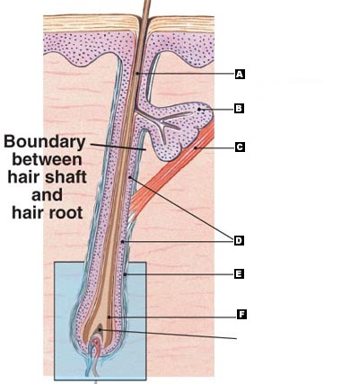What is hair composed of?

Where do hairs originate?

Label the following structures

* root
* shaft
* hair papilla
* hair bulb
* sensory nerve aka root hair plexus
* medulla
* cortex
* cuticle
* sebaceous gland
* arrector pili muscle

Name and briefly describe the 2 types of hair found on the body.

1

2

What is meant by club hair?

How many hairs does the average adult lose from their head each day?

Describe the arrector pili muscle. Where is it located? What does it do?

What condition is caused when the arrector pili muscle has contracted?

What might cause the arrector pili muscle to contract?

Page 171, 19-21

**5-8 Sebaceous Glands**

What are sebaceous glands?

What do they produce?

What are the 2 types of sweat glands? __________________ and _______________________

Describe each type of sweat gland. Where are they found? Where do they secrete their product? How do the products they secrete differ? Which type of sweat gland is more common?

Explain 3 functions of merocrine (eccrine) glands.

1

2

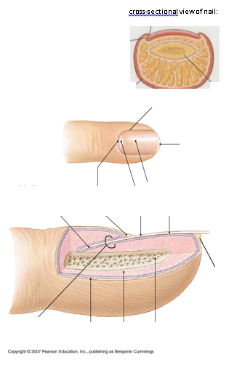 3

review questions on page 174, 22-25

**5-9 Nails**

Briefly describe the composition and function of nails.

Label the following structures: nail body, nail root, cuticle (eponychium), hyponychium

Review questions page 175, 26-28

**5-10 Skin repair**

What are the steps involved in skin repair?

What is a keloid? Is it dangerous?